Press Briefing
Whole-genome sequencing is a vital and rapidly developing method to trace the contact, source, and understand the spread of the infectious agent including novel coronavirus. Evidently, the countries introducing genome sequencing at the beginning had better success in containing the pandemic as the data acquired, empowered the policy makers to effectively act and contact-trace accordingly. The government of New Zealand and Australia sequenced the greatest number of coronavirus genomes, 25% and 75% respectively. Currently New Zealand is aiming for more than 70% to get the most complete picture. Scientists in the United Kingdom, the United States, and other countries are also sequencing SARS-CoV-2 from a large proportion of cases, but because their epidemics are still ongoing and case numbers are high, genomics is being used to monitor spread and help identify the source of some cases. Besides the developed countries, neighbouring India has already sequenced and published 1579 whole-genome sequences of novel coronavirus to better understand the viral and host genomics of the COVID-19 outbreak. Also the scientists, mapping the genetic blueprint of the novel coronavirus SARS-CoV-2, have shared more than 66,855 genome sequences from across the world on the open platform Global Initiative on Sharing All Influenza Data (GISAID) (16.07.2020).

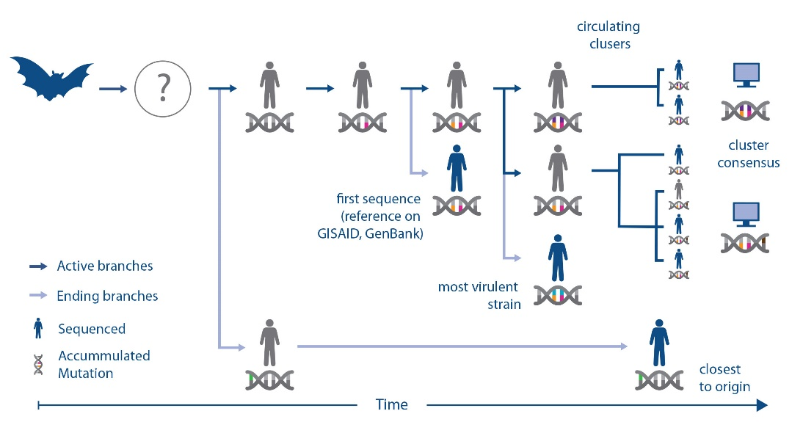

Figure: Understanding genome sequences help researchers choose the right strain of the virus for vaccine and diagnostic efforts (Source: CISRO)

Underlaying vision 2021, the government of the people’s republic of Bangladesh had established a state-of-the-art genomic research laboratory in BCSIR back in 2018. It is the only organization in Bangladesh with the facilities to perform sequencing in large numbers and generate data rapidly. In May 2020, under the initiative of honourable minister of Science & Technology, Arch. Yeafesh Osman, BCSIR has undertaken a project, encompassing the whole of Bangladesh, to collect and sequence 300 SARS-COV-2 samples. The research team has carefully established a statistically driven comprehensive plan in broad sampling and collecting associated patient data from across the country in collaboration with NILMRC (National Institute of Laboratory Medicine & Referral Centre, Bangladesh). Bangladeshi scientists have sequenced 222 whole genomes of novel coronavirus cases until the moment of writing and published in both GISAID and GenBank. Among those, 171 has successfully sequenced by the BCSIR Team, being the frontrunner in the country, under the leadership of Dr. Salim Khan (16.07.2020).

Virus genomes constantly alter (mutate) as they spread by infecting more people. These changes can be exploited to track the spread of the virus by sequencing, recording, and analysing genomes. As SARS-CoV-2 spread around the country, distinct variants began to form as viruses circulating in different regions. By comparing sequences, researchers can quickly rule out possible lines of transmission. BCSIR Team are sequencing coronavirus samples from each division to determine distinct variants for each region and preparing the usage of genomic data to help identify the probable origins of new cases.

BCSIR team has successfully identified the most virulent variant of coronavirus “D614G” which is the leading cause of infection about 94% of cases in Bangladesh. The team also found another 25 variants of coronaviruses circulating across Bangladesh based on spike protein. Currently, they are performing genetic analysis for better understanding of the genomic epidemiology, transmission dynamics, number of variants circulating in Bangladesh. The analysis is in the process of getting published in peer-reviewed journals very soon. Previously, in the 1918 influenza outbreak, it was retrospectively observed that the leading cause of the fatality was due to subsequent bacterial infections, particularly with Streptococcus pneumoniae (Morens et al., 2008). Bacterial co-infections were also associated with poor outcomes in the 2009 H1N1 influenza pandemic (MacIntyre et al., 2018). Zhou and colleagues (Zhou et al., 2020) showed that 50% of patients with COVID-19 who have died due to both bacterial and fungal co-infections.

BCSIR Team also found some opportunistic pathogens frequently present in the nasopharyngeal swab of COVID-19 patients. Now, they are working toward determining a possible link between the presence of those pathogens and the severity of infection or even death. The global death rate due to the COVID-19 virus is 66 infected people per million whereas it is 11 in Bangladesh. Many Bangladeshi’s consume antibiotics routinely whenever they feel unwell, regardless of confirmed bacterial infection. Thus, even though they have a primary viral infection they can inadvertently protect themselves from a secondary bacterial infection that can explain why the death rate of Bangladeshi COVID-19 patients is comparatively low. However, the occurrence of bacteria that are resistant to multiple antimicrobial agents is of increasing concern; the increase in multidrug-resistant bacterial species may make the prophylactic antibiotic treatment approach ineffective in the future. Analysis of the drug-resistance genes of COVID-19 patients may assist guiding the policy regarding antibiotic prophylaxis in these patients. The analysis of meta-transcriptome data obtained by the BCSIR team in concert with patient data may enable identification of biomarkers that can inform about disease progression, suggest treatment strategies and ultimately improving patient outcomes. Based on the observation, BCSIR team is in the process of publishing their research articles in leading public health journal.

If virus genome sequencing is undertaken rapidly and on a large-scale then it can assist epidemiologists and public health authorities in understanding how the virus is propagating. It can also assist in evaluating how effective their interventions are and help establish whether new variants are associated with particular patterns of symptoms or severity of the disease. In this regard the BCSIR team is also assisting the other research organisations and pharmaceuticals in Bangladesh with the data. BCSIR already have MoUs with prestigious institutes like University and Melbourne, Australia and University of Nottingham, UK. The BCSIR is collaborating with the bioinformatics teams of both the institutions in a number of researches targeted on COVID-19 affect on Bangladeshi demographic.

One of the aims of this study is in silico screening of the entire genome of the COVID-19 virus to get a conserved region that encodes an immunogenic protein with the attributes of good vaccine targets. BCSIR team aspires to predict the protein structure and design a new vaccine based on the sequencing data of 300 COVID-19 cases in Bangladesh. This vaccine would be the most suitable against the circulating COVID-19 virus in Bangladesh. The project is running smoothly and rapidly and once completed this blueprint will be shared with the current Vaccine Research groups around the world.

